**Week 14**

**Roll no:** 241801326

**Name:** Yogeetha A

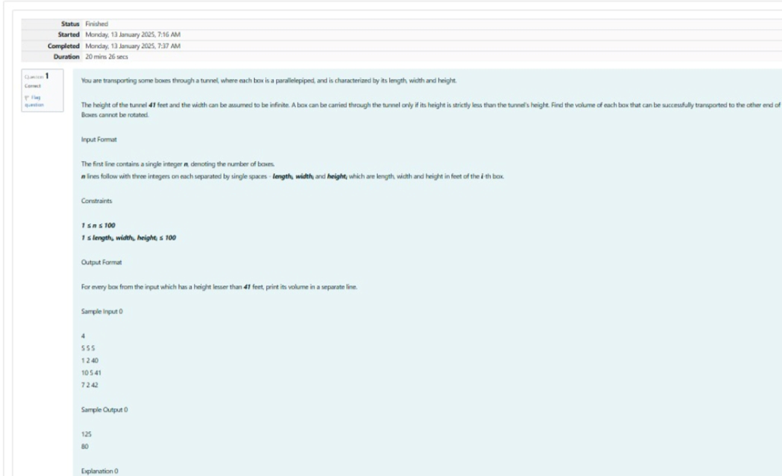

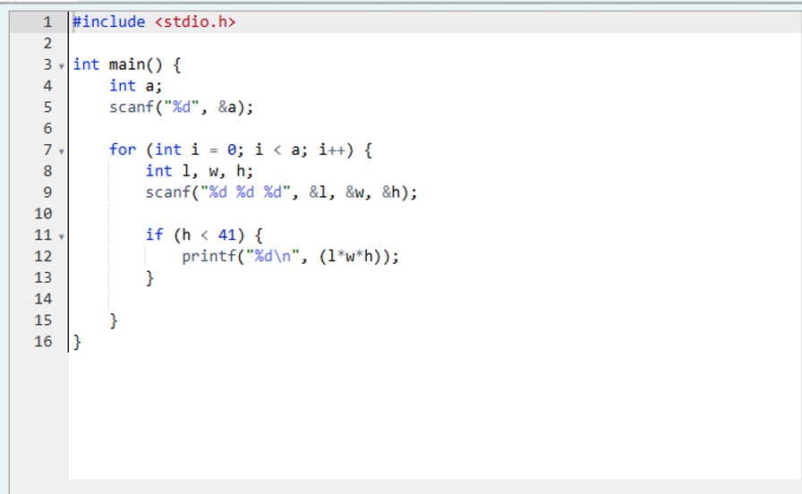

**OUTPUT:**

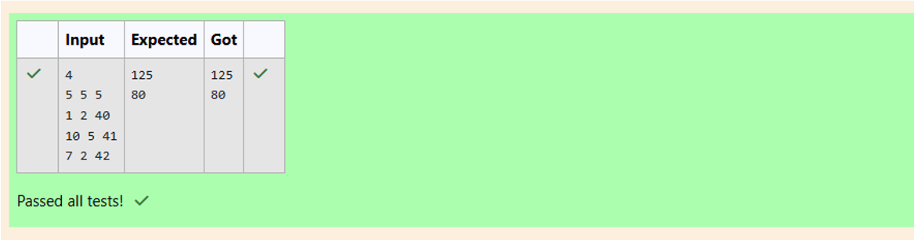

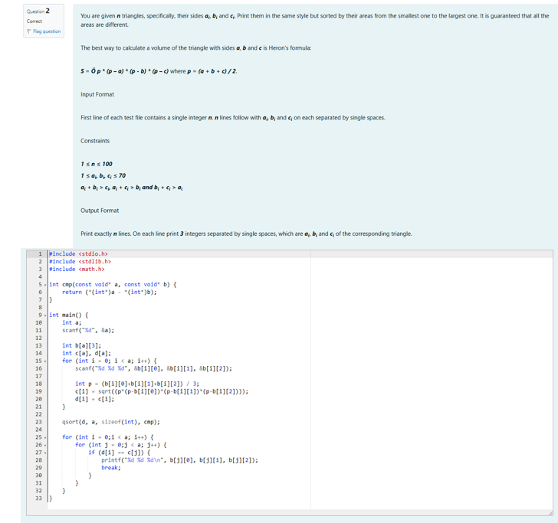

**OUTPUT:**

